1. **Plugin Installation** -   
     
   Now Go to **admin panel >> Visit Plugin Tab >> Click on add new plugin tab**

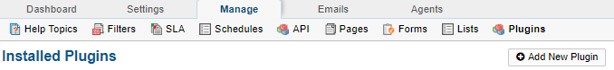 **1.Install and enable SLA AddON Plugin .   
2.Confirm   
 a. T**he new table **ost_sla_addon** created in Database

**b. admin panel >> Manage >> list   
 confirm** [SLA Response Status List](http://localhost:8012/ndev-sla/scp/lists.php?id=2) is visible with values **Missed** and **Achieved , See below Snap**

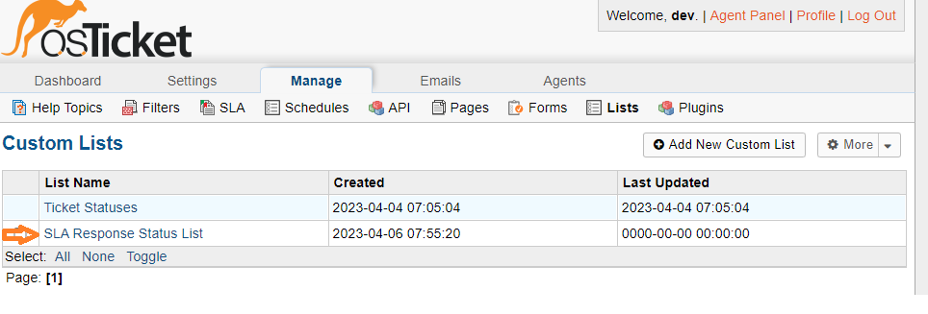

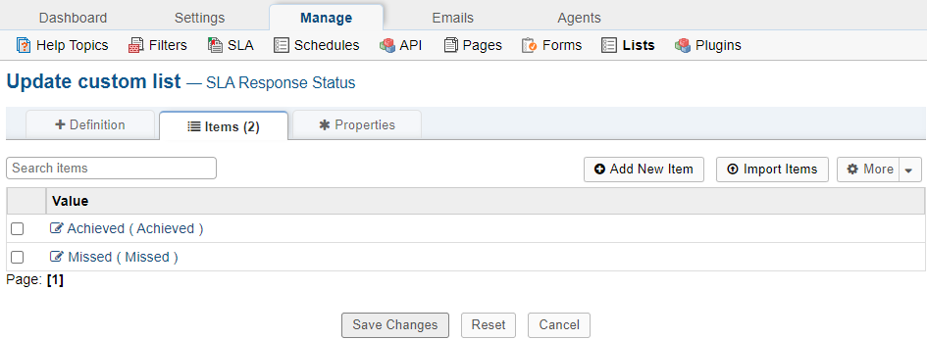

**c. admin panel >> Manage >> list >> Ticket Statuses   
 confirm new status (Awaiting response, Temporary solution provided) is** showing in this list  
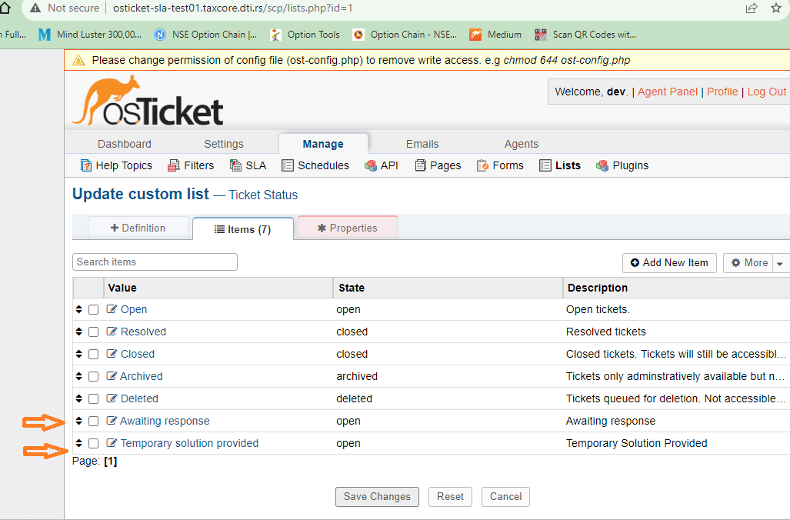

1. **Add New Plugin Instances -  
    Now we will create instance of plugin.  
   3**. Click on **plugin** >> **instances** Tab  
   **5.** Now Click on **Add New Instance** button and add instance details

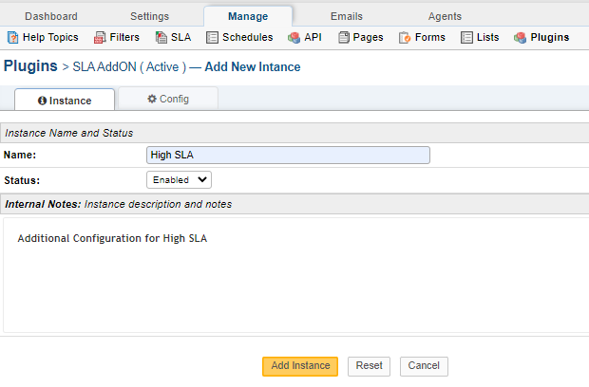

1. **Configure and Enable Instance  
     
   Choose SLA plan from all plans listed in drop down for which you want to utilise SLA Addon plugin functionality. Here you can defins the timeframe for each response .**  
   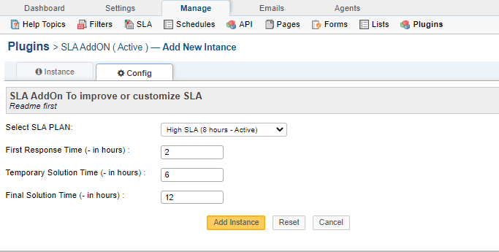  
    **Now we have added plugin configuration( New instance) for newly added sla plan “High sla”.**
   1. **Update System Default SLA**If you have default SLA in SLA Admin Menu but you have not created default SLA instance in plugin SLA settings then Default SLA will not work with SLA Plugin   
       **You need to define instance by using default SLA , so that plugin will work with default instance also.  
       You need to confirm that default sla instance having default sla entry.  
      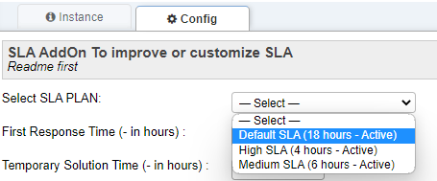  
         
        
      OR**   
      **You can update Default SLA in admin ticket settings with existing plugin SLA instance** .   
       [**http://osticket-sla-test01.taxcore.dti.rs/scp/settings.php?t=tickets**](http://osticket-sla-test01.taxcore.dti.rs/scp/settings.php?t=tickets)

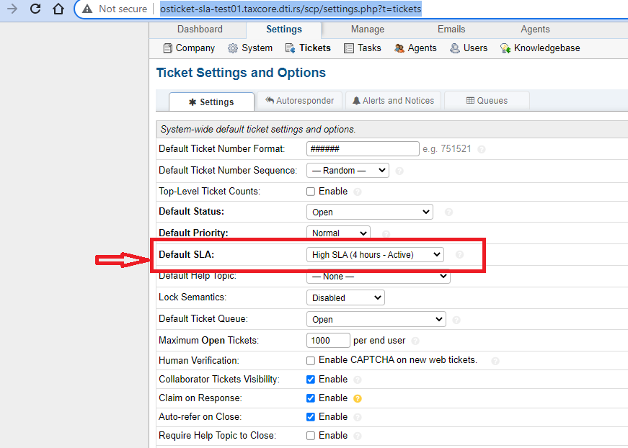

**Congratulation** , You have successfully Installed the plugin Now we will move to **next and last step for plugin configuration.**